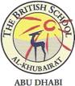

**Year 5 Islamic studies**

**Dear Parents**

**These are the topics that we need to revise for the Quiz on Wednesday 16 October:**

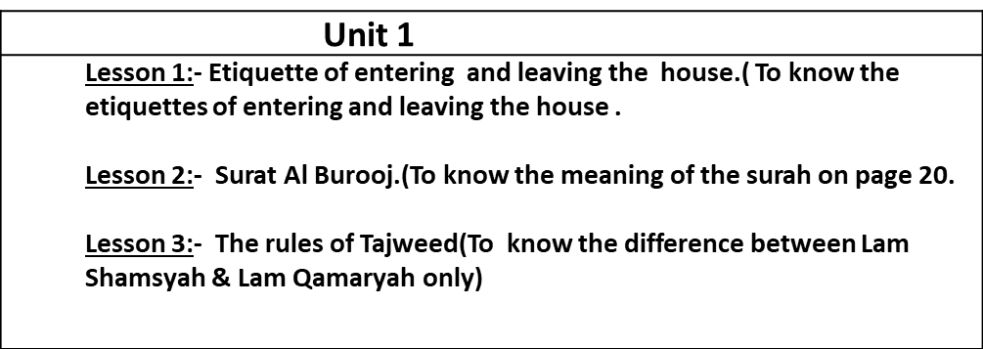

**Thank you for your co-operation.**